Water quality analysis

**INTRODUCTION:**

Water used for processing fish, washing fish or making ice is supposed to meet drinking water standards if it is to be considered safe. Reason: contaminated water is the main cause for pathogen-loading of fish, posing a serious health hazard to its consumer.

WHO has issued guidelines for drinking water quality, a report in three volumes. Vol. 1 deals with guideline values, Vol. 2 deals with each contaminant and Vol. 3 gives information on how to handle

water supplies in small rural communities. WHO recognizes that very stringent standards cannot be used universally and so a range of guideline values for more than 60 parameters have been elaborated. Most nations have their own guidelines or standards. The control exerted by local regulatory authorities may differ from place to place depending on the local situation. So how can acceptable water quality be defined? What can the harbour-master do to ensure quality? Ensuring the quality of the harbour basin when it is contiguous with estuarine or coastal waters is perhaps beyond the scope of the harbour- master except to ensure that activities in his harbour do not add to the pollution. However, he is duty- bound to ensure that the water used for drinking, cleaning fish, ice making and fish processing meets standards of potability set in his country.

Qualitative and quantitative measurements are needed from time to time to constantly monitor the

quality of water from the various sources of supply. The harbour-master should then ensure appropriate water treatment within the fishery harbour complex as well as initiate remedial measures with the

suppliers when water supply from outside is polluted.

Water sampling and analysis should be done by ISO-certified laboratories. Wherever laboratories available locally are not ISO-certified, it is advisable to get their quality assessed by an ISO-certified laboratory by carrying out collaborative tests to ensure that variation in the accuracy of results is

sufficiently small. Unreliable results exacerbate problems of pollution when corrective action cannot be taken in time. Sampling and monitoring tests should be carried out by qualified technicians.

Depending on the actual state of the fishing harbour infrastructure and environmental conditions in and around the harbour, monitoring should be carried out according to a specific programme for each source of water supply.

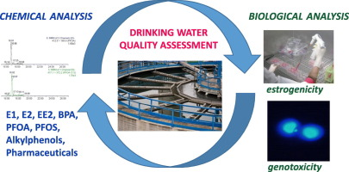

**AIM:**

Water quality analysis is to assess and understand the physical, chemical, and biological characteristics of a body of water. This analysis is typically conducted to determine whether the water meets specific quality standards, identify potential contaminants or pollutants, and make informed decisions about water treatment or environmental management.

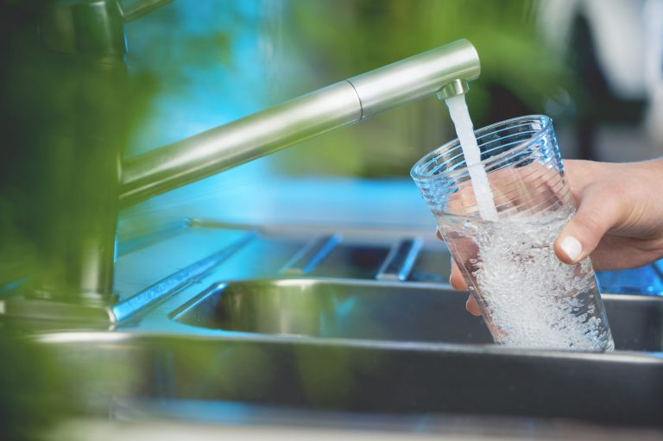

* + 1. BOREWELLS:

Contamination may arise from pollutants entering the water table some distance from the port or from sewage entering the borehole itself in the port area through cracked or corroded casings. In cases where overdrawing is evident (water is brackish), tests should be conducted at least monthly.

* + 1. MUNICIPAL MAINS:

Supply could be contaminated at source or through corroded pipelines leading to the fishery harbour. Mixing with sewage lines due to defective piping has been known to occur often. Complete tests should be carried out every half year, and the authorities should be informed when results indicate

contamination.

* + 1. WATER TANKS AND RESERVOIRS:

Both types of structure are prone to bacterial growth if the residual chlorine levels in them are low or non-existent. Testing may not be necessary if periodic scrubbing is carried out. Bacteriological tests should be done at least half-yearly.

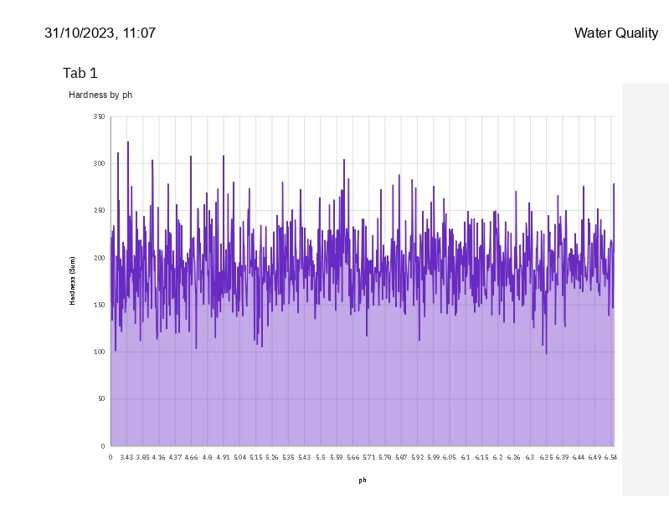

* + 1. HARBOUR BASIN WATER:

Typically, harbour basins are tested yearly. However, in areas where monsoons are very active, it may be advisable to test at the peak of the dry season when effluent point discharges tend to remain

concentrated in the water body and again during the wet season when agriculture run-off may be considerable. Another critical period for harbours is the peak of the fishing season when the harbour is at its busiest and vessel-generated pollution is likely to be at its peak.

While the details of sampling, testing and analysis are beyond the scope of this handbook, what follows is a general description of the significance of water quality tests usually made.

Testing procedures and parameters may be grouped into physical, chemical, bacteriological and microscopic categories.

* Physical tests indicate properties detectable by the senses.
* Chemical tests determine the amounts of mineral and organic substances that affect water quality.
* Bacteriological tests show the presence of bacteria, characteristic of faecal pollution.

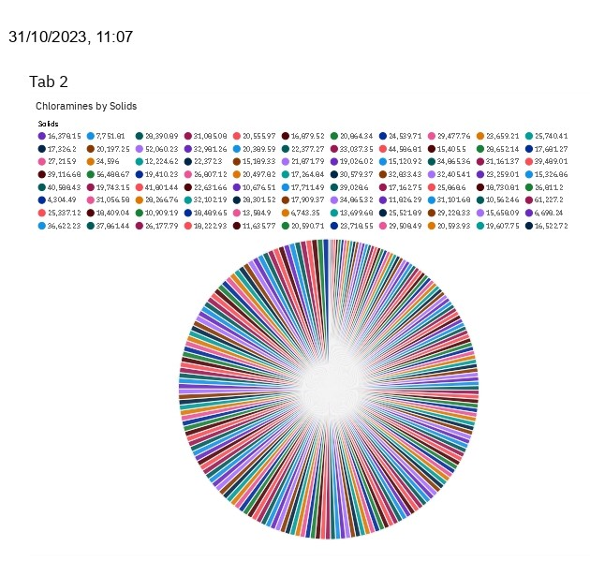

* + 1. PHYSICAL TESTS:

Colour, turbidity, total solids, dissolved solids, suspended solids, odour and taste are recorded.

Colour in water may be caused by the presence of minerals such as iron and manganese or by substances of vegetable origin such as algae and weeds. Colour tests indicate the efficacy of the water treatment system.

Turbidity in water is because of suspended solids and colloidal matter. It may be due to eroded soil caused by dredging or due to the growth of micro-organisms. High turbidity makes filtration expensive. If sewage solids are present, pathogens may be encased in the particles and escape the action of chlorine during disinfection.

Odour and taste are associated with the presence of living microscopic organisms; or decaying organic matter including weeds, algae; or industrial wastes containing ammonia, phenols, halogens,

hydrocarbons. This taste is imparted to fish, rendering them unpalatable. While chlorination dilutes odour and taste caused by some contaminants, it generates a foul odour itself when added to waters polluted with detergents, algae and some other wastes.

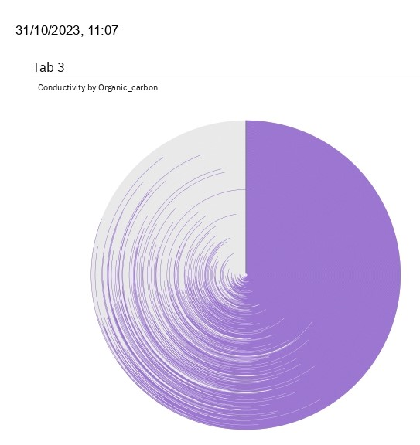

* + 1. CHEMICAL TESTS:

pH, hardness, presence of a selected group of chemical parameters, biocides, highly toxic chemicals, and

B.O.D are estimated.

pH is a measure of hydrogen ion concentration. It is an indicator of relative acidity or alkalinity of water.

Values of 9.5 and above indicate high alkalinity while values of 3 and below indicate acidity. Low pH

values help in effective chlorination but cause problems with corrosion. Values below 4 generally do not support living organisms in the marine environment. Drinking water should have a pH between 6.5 and

8.5. Harbour basin water can vary between 6 and 9.

B.O.D.: It denotes the amount of oxygen needed by micro-organisms for stabilization of decomposable organic matter under aerobic conditions. High B.O.D. means that there is less of oxygen to support life and indicates organic pollution.

* + 1. BACTERIOLOGICAL TESTS:

For technical and economic reasons, analytical procedures for the detection of harmful organisms are impractical for routine water quality surveillance. It must be appreciated that all that bacteriological analysis can prove is that, at the time of examination, contamination or bacteria indicative of faecal pollution, could or could not be demonstrated in a given sample of water using specified culture

methods. In addition, the results of routine bacteriological examination must always be interpreted in the light of a thorough knowledge of the water supplies, including their source, treatment, and

distribution.

Whenever changes in conditions lead to deterioration in the quality of the water supplied, or even if they should suggest an increased possibility of contamination, the frequency of bacteriological

examination should be increased, so that a series of samples from well chosen locations may identify the hazard and allow remedial action to be taken. Whenever a sanitary survey, including visual inspection, indicates that a water supply is obviously subject to pollution, remedial action must be taken,

irrespective of the results of bacteriological examination. For unpiped rural supplies, sanitary surveys may often be the only form of examination that can be undertaken regularly.

The recognition that microbial infections can be waterborne has led to the development of methods for routine examination to ensure that water intended for human consumption is free from excremental pollution. Although it is now possible to detect the presence of many pathogens in water, the methods of isolation and enumeration are often complex and time-consuming. It is therefore impractical to

monitor drinking water for every possible microbial pathogen that might occur with contamination. A more logical approach is the detection of organisms normally present in the faeces of man and other warm-blooded animals as indicators of excremental pollution, as well as of the efficacy of water

treatment and disinfection. The presence of such organisms indicates the presence of faecal material and thus of intestinal pathogens. (The intestinal tract of man contains countless rod-shaped bacteria known as coliform organisms and each person discharges from 100 to 400 billion coliform organisms per day in addition to other kinds of bacteria). Conversely, the absence of faecal commensal organisms

indicates that pathogens are probably also absent. Search for such indicators of faecal pollution thus provides a means of quality control. The use of normal intestinal organisms as indicators of faecal

pollution rather than the pathogens themselves is a universally accepted principle for monitoring and assessing the microbial safety of water supplies. Ideally, the finding of such indicator bacteria should denote the possible presence of all relevant pathogens.

Indicator organisms should be abundant in excrement but absent, or present only in small numbers, in other sources; they should be easily isolated, identified and enumerated and should be unable to grow in water. They should also survive longer than pathogens in water and be more resistant to disinfectants, such as chlorine. In practice, these criteria cannot all be met by any one organism, although many of

them are fulfilled by coliform organisms, especially Escherichia coli as the essential indicator of pollution by faecal material of human or animal origin.

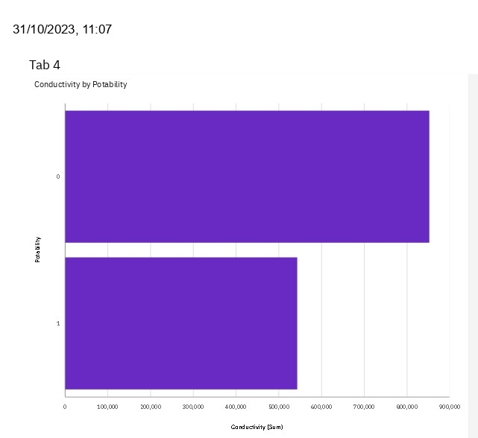

A harbour master’s knowledge of the state of the environment in and around the fishing harbour goes a long way toward preventing outbreaks of contamination or disease with subsequent loss of resources and income. This is particularly so for the many small-to-medium fishing ports scattered around

coastlines in developing countries, where, more often than not, environmental help and support from central bodies is meagre and very time-consuming.

The following is a true-life example of an investigative analysis carried out in an ASEAN country in a harbour that was experiencing problems with hygiene (coliform contaminated fish).

The main advantages of using chlorine gas are:

* It is the most efficient method of making free chlorine available to raw water.
* It lowers the pH of the water slightly.
* Control is simple; testing simple; and it is not an expensive method.

The main disadvantages are:

* Chlorine gas is toxic and can combine with other chemicals to form combustible and explosive materials.
* Automatic control systems are expensive.
* Chlorine cylinders may not be readily available at small centres.
* Chlorine expands rapidly on heating and hence the cylinders must have fusible plugs set at 70°C. It also reacts with water, releasing heat. Water should not therefore be sprayed on a leaking
* cylinder.Hypochlorites are generally available in two forms – sodium hypochlorite solution normally available at 10% concentration and calcium hypochlorite available as a powder.

The main disadvantages of using hypochlorites are:

* Calcium hypochlorite is not stable and must be stored in air-tight drums.
* Sodium hypochlorite is quite corrosive and cannot be stored in metal containers
* Sodium hypochlorite must be stored in light proof containers.
* It is difficult to control the rate of addition of hypochlorites in proportion to water flow.
* Hypochlorites raise the pH in water.
* They are more expensive than chlorine gas.

It is important to understand the manner in which chlorine or chlorine-releasing substances behave when added to water, depending on other substances present.

* When water contains reducing substances like ferrous salts or hydrogen sulphide, these will reduce part of the added chlorine to chloride ions.
* When water contains ammonia, organic matter, bacteria and other substances capable of reacting with chlorine, the level of free chlorine will be reduced.
* If the quantity of chlorine added is sufficiently large to ensure that it is not all reduced or combined, a portion of it will remain free in the water. This is termed as residual free chlorine or free chlorine.

When chlorine reacts chemically as in the first two cases, it loses its oxidising power and consequently its disinfecting properties. Some ammoniacal chlorides however still retain some disinfecting properties.

Chlorine present in this form is termed residual combined chlorine or combined chlorine.

From the standpoint of disinfection, the most important form is free chlorine. Routine analysis always aims at determining at least the free chlorine level.

Ozone treatment: Though the principle is relatively simple, this method needs special equipment, supply of pure oxygen and trained operators. Ozone is generated by passing pure oxygen through an ozone

generator. It is then bubbled through a gas diffuser at the bottom of an absorption column, in a direction opposite to the flow of raw water. Retention or contact time is critical and the size of the absorption column depends on the water flow.

The main advantages of ozone treatment are:

* Ozone is a much more powerful germicide than chlorine especially for faecal bacteria.
* It reduces turbidity of water by breaking down organic constituents.
* The process is easily controlled.

The disadvantages are:

* Pure oxygen may not be readily available locally.
* Ozonized water is corrosive to metal piping.
* Ozone decomposes rapidly into oxygen.
* Water has to be aerated prior to use to remove the ozone.

Ultraviolet irradiation treatment: This method is often used to treat drinking water. Successful commercial installations have been made to purify sea water in large fish processing plants.

The main advantages of U-V treatment are:

* U-V rays in the range of 2500-2600 Angstrom units are lethal to all types of bacteria.
* There is no organoleptic, chemical or physical change to the water quality.
* Overexposure does not have any ill effects.

The main disadvantages are:

* Electricity supply should be reliable.
* Turbidity reduces efficiency.
* Water may require prior treatment like filtration.
* The unit requires regular inspection and maintenance.
* Thickness of the water film should not exceed 7.5 cm.

Membrane filtration: Osmotic membrane treatment methods are generally expensive for commercial scale installations. Combinations of membrane treatment with U-V treatment units are available for domestic use.

2.4.2 Secondary treatment

Secondary treatment of water consists of sedimentation and filtration followed by chlorination.

Sedimentation can be carried out by holding the raw water in ponds or tanks. The four basic types of filtration are cartridge filtration, rapid sand filtration, multimedia sand filtration, and up-flow filtration.

Cartridge filtration: This system is designed to handle waters of low turbidity and will remove solids in the 5 to 100 micron range.

The main advantages are:

* Low cost and ‘in-line’ installation.
* Change of cartridge is simple.
* Operation is fool-proof. Once the cartridge is clogged, flow simply stops.

The main disadvantages are:

* Sudden increase in turbidity overloads the system.
* Cartridges may not be readily available and large stocks may be required.

Rapid sand filtration: This system consists of a layer of gravel with layers of sand of decreasing

coarseness above the gravel. As solids build up on top, flow decreases until it stops. This is corrected by back-flushing the system to remove the solid build up on top, Figure 12.

The main advantages are:

* The cost of filtration media is negligible.
* The operation is simple.

The main disadvantages are:

* A holding tank for filtered water is required to provide clear water back flushing.

Pumping loads increase as sediments build up the main disadvantage is:

* Close supervision is necessary to ensure that the filter bed does not rupture.

2.4.3 COMPLETE TREATMENT:

Complete treatment consists of flocculation, coagulation, sedimentation and filtration followed by disinfection. Flocculation and coagulation will assist in removing contaminants in the water, causing

turbidity, colour odour and taste which cannot be removed by sedimentation alone. This can be achieved by the addition of lime to make the water slightly alkaline, followed by the addition of coagulants like Alum (aluminium sulphate), ferric sulphate or ferric chloride. The resultant precipitate can be removed

by sedimentation and filtration.

Chemical treatment may be required to reduce excessive levels of iron, manganese, chalk, and organic matter. Such treatment is usually followed by clarification. Iron may be removed by aeration or

chlorination to produce a flocculant which can be removed by filtration. Manganese may be removed by aeration followed by adjustment of pH and up-flow filtration. Most colours can be removed by treatment with ferric sulphate to precipitate the colours.

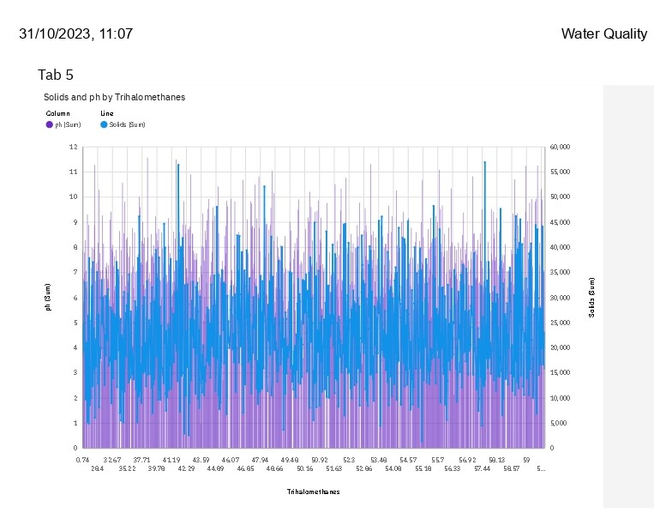

**IMPOTANT LIBRARIES:**

LINEAR ALGEBRA:

import numpy as np

DATA PROCESSING:

import pandas as pd

INPUT DATA FILES read_only:

import os  
for dirname, _, filenames **in** os.walk('/kaggle/input'):  
 for filename **in** filenames:  
 print(os.path.join(dirname, filename))  
  
  
IMPORT THE DATA:

Dataframed=pd.read_csv("input/water potability/water_potability.csv")

INPUT THE HEAD:

dataframed.head()

ADDING COLUMNS AND VALUES:

dataframed.columns.values.tolist()

['ph',  
 'Hardness',  
 'Solids',  
 'Chloramines',  
 'Sulfate',  
 'Conductivity',  
 'Organic_carbon',  
 'Trihalomethanes',  
 'Turbidity',  
 'Potability']

GET INFORMATION:

dataframed.info()

<class 'pandas.core.frame.DataFrame'>  
RangeIndex: 3276 entries, 0 to 3275  
Data columns (total 10 columns):  
 # Column Non-Null Count Dtype   
--- ------ -------------- -----   
 0 ph 2785 non-null float64  
 1 Hardness 3276 non-null float64  
 2 Solids 3276 non-null float64  
 3 Chloramines 3276 non-null float64  
 4 Sulfate 2495 non-null float64  
 5 Conductivity 3276 non-null float64  
 6 Organic_carbon 3276 non-null float64  
 7 Trihalomethanes 3114 non-null float64  
 8 Turbidity 3276 non-null float64  
 9 Potability 3276 non-null int64   
dtypes: float64(9), int64(1)  
memory usage: 256.1 KB

RETURNS DESCRIPTION:

dataframed.describe()

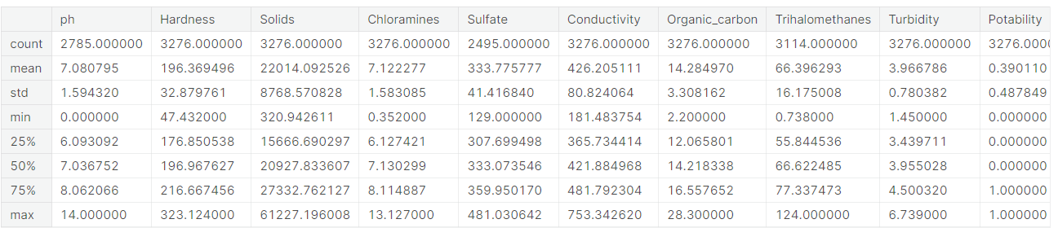

# MISSING VALUES:

dataframed.isnull().sum()

# DATA CLEANING:

## In this phase, the team focused on the visualization and treatment of missing values to prepare the data for the exploratory data analysis and model building phase. Dealing with missing values is very important for creating a powerful prediction model, therefore, this phase is vital for the study's success.

# MISSING VALUES VISUALIZATION:

import missingno as msno  
msno.matrix(dataframed)  
plt.show()

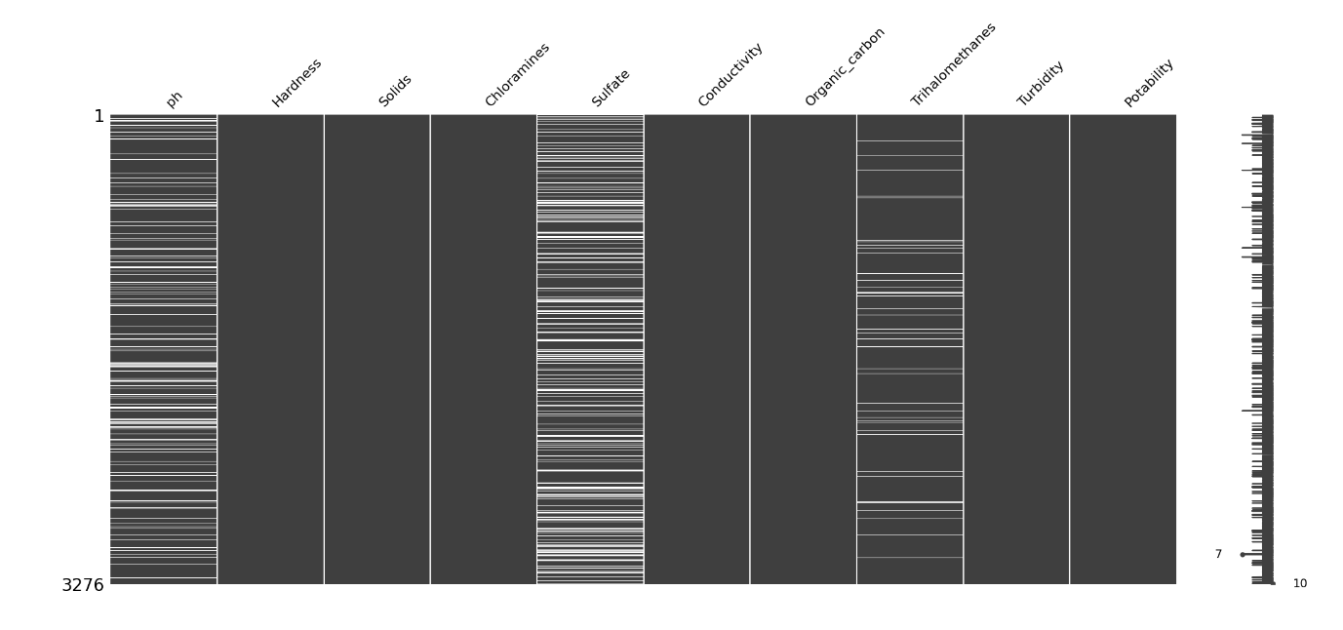

**CONCLUSION:**

Maintaining and improving water quality is a shared responsibility that requires the concerted effort of all stakeholders. This analysis serves as a foundation for informed decision-making and action towards ensuring clean and safe water for the community and the environment. It is imperative to act promptly and diligently to safeguard our water resources for current and future generations.